Paper Title (Maximum 2 lines)
1st author's name¹, 2nd author's name², … (Please underline the presenter's name)
¹1st author's title, affiliation and country, 1st author's email
²2ndauthor's title, affiliation and country, 1st author's email
…

Abstract- This electronic document is a “live” template and defines the components of your paper [title, text, heads, etc.] in its style sheet. Please do not use symbols, special characters, or math in paper title or abstract. Maximum 250 words.
Keywords: Component; Formatting; Styling (3-6 key words)

Introduction (Heading 1)
This template, modified in MS Word and saved as a “Word 97-2003 Document” for the PC, provides authors with most of the formatting specifications needed for preparing electronic versions of their papers. Margins, column widths, line spacing, and type styles are built-in; examples of the type styles are provided throughout this document and are identified in italic type, within parentheses, following the example. Some components, such as multi-leveled equations, graphics, and tables are not prescribed, although the various table text styles are provided. The formatter will need to create these components, incorporating the applicable criteria that follow.

Materials and Experimentalprocedures

Selecting a Template (Heading 2)
First, confirm that you have the correct template for your paper size. This template has been tailored for output on the A4 paper size.

Results and Discussion
The template is used to format your paper and style the text. All margins, column widths, line spaces, and text fonts are prescribed; please do not alter them. You may note peculiarities. For example, the head margin in this template measures proportionately more than is customary. This measurement and others are deliberate, using specifications that anticipate your paper as one part of the entire proceedings, and not as an independent document. Please do not revise any of the current designations.

Formatting
Do not use hard tabs, and limit use of hard returns to only one return at the end of a paragraph. Do not add any kind of pagination anywhere in the paper. Do not number text heads-the template will do that for you.

Abbreviations and Acronyms
Define abbreviations and acronyms the first time they are used in the text, even after they have been defined in the abstract. Do not use abbreviations in the title or heads unless they are unavoidable.

Units
- Use SI units. English units may be used as secondary units (in parentheses). If you must use mixed units, clearly state the units for each quantity that you use in an equation.
- Do not mix complete spellings and abbreviations of units: “Wb/m²” or “webers per square meter,” not “webers/m².” Spell units when they appear in text: “...a few henries,” not “...a few H.”
- Use a zero before decimal points: “0.25,” not “.25.” Use “cm³,” not “cc.” (bullet list)

Equations
Please type equations using either the Times New Roman or the Symbol font. Number equations consecutively. Place equation numbersin parentheses, as in
a  b                     
Use “(1),” not “Eq. (1)” or “equation (1),” except at the beginning of a sentence: “Equation (1) is ...”. Note that the equation is centered using a center tab stop. Be sure that the symbols in your equation have been defined before or immediately following the equation.
Italicize Roman symbols for quantities and variables, but not Greek symbols.
An excellent style manual for science writers is [7].

sub-topics
If there are two or more sub-topics, the next level head (uppercase Roman numerals) should be used and, conversely, if there are not at least two sub-topics, then no subheads should be introduced. Styles named “Heading 1,” “Heading 2,” “Heading 3,” and “Heading 4” are prescribed.

Figures and Tables

Positioning Figures and Tables: Place figures and tables at the top and bottom of pages. Avoid placing them in the middle of pages. Figure captions should be below the figures; table heads should appear above the tables. Insert figures and tables after they are cited in the text. Use the abbreviation “Fig. 1,” even at the beginning of a sentence.

Please use tables (No Borders)to insert graphics in the paper. Insert graphics in the tables using "Insert Pictures" command. Each graphic needs to be a minimum 300 dpi resolution TIFF or EPS file with all fonts embedded.

- Table Styles
Table Head | Table Column Head
 | Table column subhead | Subhead | Subhead
copy | More table copyª
- Sample of a Table footnote. (Table footnote)
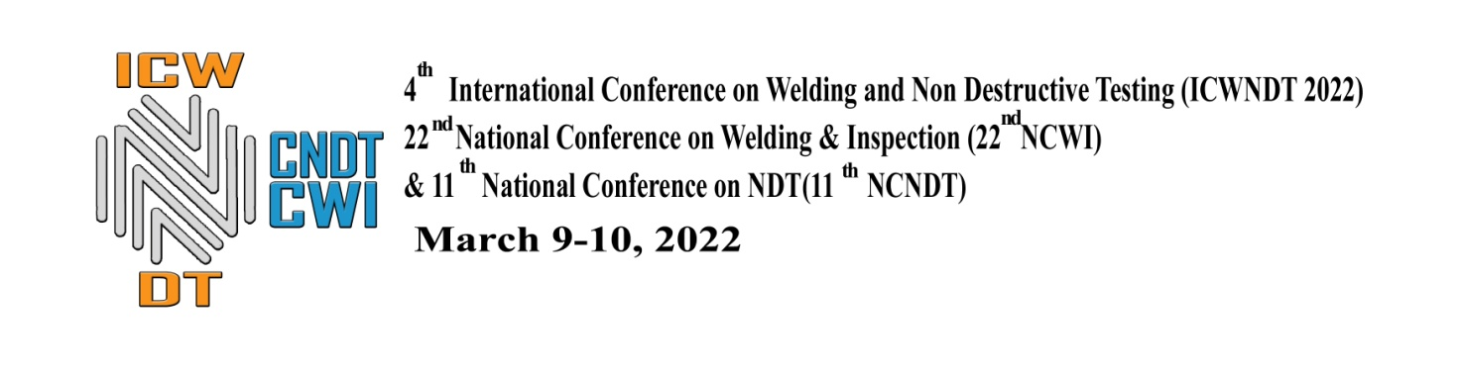
- Example of a figure caption. (figure caption

Figure Labels: Use 8 point Times New Roman for Figure labels. Use words rather than symbols or abbreviations when writing Figure axis labels to avoid confusing the reader. As an example, write the quantity “Magnetization,” or “Magnetization, M,” not just “M.” If including units in the label, present them within parentheses. Do not label axes only with units. In the example, write “Magnetization (A/m)” or “Magnetization (Am⁻¹),” not just “A/m.” Do not label axes with a ratio of quantities and units. For example, write “Temperature (K),” not “Temperature/K.”

Conclusions
Main findings of the papers, Main findings of the papers, Main findings of the papers, Main findings of the papers, Main findings of the papers, Main findings of the papers, Main findings of the papers, Main findings of the papers, Main findings of the papers, Main findings of the papers, Main findings of the papers, Main findings of the papers.

Acknowledgment (Heading 5)
Name the persons/institutions who have supported the work (Optional).

References
[1]. The sentence punctuation follows the bracket [2]. Refer simply to the reference number, as in [3]—do not use “Ref. [3]” or “reference [3]” except at the beginning of a sentence: “Reference [3] was the first ...”
Number footnotes separately in superscripts. Place the actual footnote at the bottom of the page in which it was cited. Do not put footnotes in the reference list. Use letters for table footnotes.
Unless there are six authors or more give all authors’ names; do not use “et al.”. Papers that have not been published, even if they have been submitted for publication, should be cited as “unpublished” [4]. Papers that have been accepted for publication should be cited as “in press” [5]. Capitalize only the first word in a paper title, except for proper nouns and element symbols.
For papers published in translation journals, please give the English citation first, followed by the original foreign-language citation [6].

